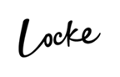

Mural Farmhouse opens at WunderLocke

The latest gourmet destination from Michelin-starred restaurant Mural, under the lead of Chef Rico Birndt

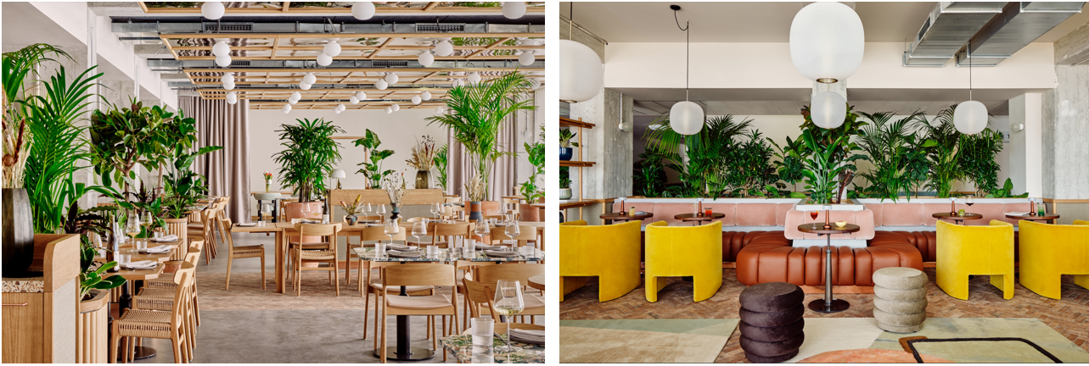
Mural Farmhouse à la carte-Restaurant |Mural Farmhouse Café

This autumn, Locke’s latest European opening - WunderLocke, in Sendling, Munich, will unveil a food and drink concept unparalleled in Germany in the form of ‘Mural Farmhouse’: five food and drink destinations spread across seven floors following one strict culinary concept: From farm directly to table.

Conceived by the founders of revered local Michelin-starred restaurant - Mural, Moritz Meyn and Wolfgang Hingerl bring to WunderLocke Munich’s new must-visit restaurant and bar destination. The ambitious food and drink concept includes ‘Mural Farmhouse à la carte-Restaurant’, a 70-cover all-day restaurant, ‘Mural Farmhouse Fine Dining’, a fine dining experience with a tasting menu, ‘Mural Farmhouse Café’, a coffee shop with fresh pastries and more, an Italian disco inspired wine and cocktail bar ‘Mural Farmhouse Bar’ and ‘Mural Farmhouse Rooftop’, a rooftop boasting a farm and outdoor bar with panoramic views of the Bavarian Alps. The vision for Mural Farmhouse has been developed in collaboration with internationally recognised Chef Rico Birndt (formally of Pasture in New Zealand, and Lakeside in Hamburg) who has taken up the position as Head Chef at Mural Farmhouse, responsible for all five of the outlets.

Placing circularity at the heart of its approach, Mural Farmhouse is founded on the principles of the farm-to-table movement and Mural’s “Eat Local. Drink Natural” ethos. Seasonal herbs and certain vegetables used in Mural Farmhouse's five outlets will come from WunderLocke’s own rooftop garden and additional (raised) beds, while fish, meat and all other vegetables and fruit will be sourced exclusively from local and regional producers and suppliers in the city of and around Munich who are committed to natural cultivation and animal welfare.

In keeping with the interiors throughout WunderLocke, the designs for Mural Farmhouse were created by interior architects Holloway Li and keeping with the wider project, focus on the themes of renewal and connections to nature, bridging the local area’s industrial heritage with the wilderness of the Bavarian forests and parkland to the south of the city.

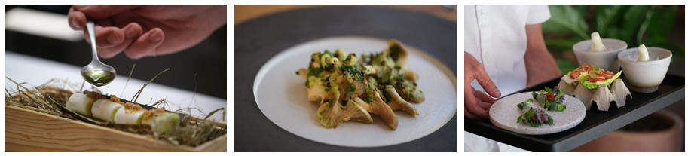
Mural Farmhouse, credit: Lenka Li Lilling

The menus at each of Mural Farmhouse’s five destinations have been imaginatively designed in connection with each other to maximise the use of seasonal ingredients. Whether guests choose to dine at Mural Farmhouse Fine Dining - the sixteen-seat location, or at Mural Farmhouse Restaurant - the all-day a la carte restaurant, the quality of the produce is consistent, yet each dish is reimagined to suit the personality of each unique venue.

“Every time a guest dines with us – whether it’s for the first time, or the fifth time; at our Fine Dining, or cocktail bar – I want them to leave surprised. By approaching the project through the lens of sustainability, we’ve challenged ourselves to experiment with new cooking methods, which has resulted in a truly memorable menu that celebrates seasonality in its purest form.” – Rico Birndt, Head Chef, Mural Farmhouse

"We have had the idea for a unique gastronomic concept like Mural Farmhouse for a long time. From breakfast through to the relaxed fine dining menu, we wanted to provide guests with a unique culinary experience. With partners like edyn this vision was able to be realised as they were just as enthusiastic about this perfect match between a unique hotel and a top gastronomy offering which is open to all guests and pays equal attention to the visual delight as well as the quality.” – Moritz Meyn, Founder and Co-CEO, Mural.

“After working with Mural to create BAMBULE! our brilliant food and drink destination at Schwan Locke, we knew that they were the perfect partners to create an unparalleled and distinctive offering at WunderLocke. In keeping with Locke’s ethos, Mural believe in the importance of providing guests with a unique experience and we are delighted to be able to deliver this across Mural Farmhouse’s five destinations in WunderLocke.” – Eric Jafari, Chief Development Officer & Creative Director, edyn.

Mural Farmhouse Fine Dining

Mural Farmhouse Fine Dining includes a Chef’s Table with 16 seats, and a tasting menu that is served in 12 or 14 courses. The purity of individual ingredients and their surprising combination is the focus of Chef Rico Birndt's gourmet cuisine, dishes to highlight include the Leek Yeast Camomille, alongside the Seatrout Verbena Flowering Quince Miso. The design by Holloway Li is ideal for larger group settings, with a central table surrounded by contemporary teal dining chairs. Bespoke ceiling lights and a soft and tactile curtain create intimacy.

Mural Farmhouse à la carte-Restaurant

Mural Farmhouse à la carte-Restaurant is an all-day restaurant with a capacity of 70-seats and an outdoor area with a fire pit, open for lunch and dinner, as well as breakfast for guests. The restaurant has a private dining area which can be expanded for events or conferences by opening up a series of sliding partitions to include the business suite venue beyond. Clever design effects have been incorporated by Holloway Li, including a rippled mirrored ceiling which creates the optical illusion of a liquid reflection. As an extension of the concept, the designers filled the restaurant space with plants and natural tones with finishes that echo the pink, earthy and green tones from the bar. Terracotta planters compliment the red tones of timber, upholstery, and copper skirting which punctuate the space.

Mural Farmhouse Café

The Mural Farmhouse Café located on the ground floor incorporates a round bar, designed by Holloway Li, which encourages lingering. Internally, design elements include detailing such as an upholstered bar top - a trope of 70’s dive bars that encourages patrons to take root and get comfy. Riffing off Mural’s culinary concepts, Holloway Li chose dense free-flowing planting, referencing the nearby Grünwald Forest. Natural materials such as timber, terrazzo and raffia were selected to chime with Mural’s sustainable and seasonal fare.

Mural Farmhouse Bar
The impressive Mural Farmhouse Bar, located on the 7th floor, is an interplay of opposites inspired by the Italian disco movement of the late 1970’s. As guests enter, they are greeted by muted colours and velvet with dark wood panelling. Fully glazed windows dominate the room to the left and right of the bar, with one window offering a view of the Alps, and the other over Munich. The bathrooms are a hidden gem, with a completely different style and design, sure to become the ‘photo’ spot.

Mural Farmhouse Rooftop

Later on in the year for autumn/winter 2022, the most spectacular area of Mural Farmhouse will open: the Rooftop. Here, 1,000 square meters of an urban garden creates a unique rooftop experience, with a bar and seating area and panoramic views south to the Alps and north over the city of Munich, creating a completely unique experience for guests and locals alike.

For bookings please visit the website: HERE
***ENDS***

For press enquiries please contact: locke@purplepr.com
Follow @lockehotels on Facebook and Instagram.
For more information, please visit: www.lockeliving.com/en
About Locke:
Locke believes that life shouldn’t stop when you’re away from home, giving guests the freedom to travel on their own terms by creating spaces that are designed to adapt to travellers ever-changing lifestyles.
Since the opening of its first location in 2016 in London, the brand has expanded rapidly, currently operating 12 trading properties and 2,127 trading keys across five markets in the UK and mainland Europe.
Locke’s signature studio and one-bed suites are designed to offer business and leisure travellers more autonomy and flexibility than a typical hotel, suitable for either short or extended stays. Each Locke is designed around the local community, with unique interiors, and food and drink partners, which reflect and celebrate the culture and character of the different neighbourhoods in which they’re located.
Locke is part of the edyn family, a pioneering hospitality group which also operates bespoke serviced apartments brands, Cove and Saco.
For more information, please visit: https://www.lockeliving.com/en
About edyn:
edyn is a pioneering hospitality group that is revolutionising the extended stay sector. edyn was built on the philosophy that travel should be a rich journey of discovery, providing unique experiences that inspire, whether travelling for business or leisure. For almost 25 years, the group has expressed this vision through the development of a unique and diverse portfolio of properties reflecting the evolution of the travel and hospitality industries.
The group owns and operates an extensive range of properties across the UK and Europe, including its lifestyle aparthotel brand Locke, future-facing serviced apartment brand Cove and Saco, which offers spacious, comfortable accommodation across the UK. Together, alongside an extensive partner network, edyn has established a global ecosystem consisting of more than 80,000 apartments in 260 locations.

For more information, please visit: www.findingedyn.com

About Holloway Li:
Holloway Li was founded by creative Interior Architect duo Alex Holloway and Na Li. The studio’s built work covers a diverse catalogue covering retail spaces, hospitality, and select private homes. Recently completed projects include Bermonds Locke, a brand new edition of edyn’s apartment hotel concept Locke, a rooftop extension for the boutique hotel The Hoxton and a new concept showroom for bathroom brand Coalbrook. Upcoming projects include a 280-room modular apartment hotel in Canary Wharf for Locke and a series of private houses.
For more information, visit: hollowayli.com
About Mural:
Mural was founded in its current form in 2012 by Moritz Meyn and Wolfgang Hingerl and currently consists of the Mural Restaurant (one Michelin Star since 2020), the Bar Mural (Bib Gourmand since 2021) as well as the Mural Day Bar, BAMBULE! at Schwan Locke and Mural Farmhouse at WunderLocke - all located in Munich. All Mural venues follow the same vision of a new eating and drinking culture: eat local, drink natural and a strict farm-to-table principle for all ingredients. Mural's own web store offers gourmets homemade delicacies.

For more information, visit: muralrestaurant.de

About Chef Rico Birndt:
Rico Birndt, Head Chef at Mural Farmhouse, is responsible for all locations at Mural Farmhouse - from the Fine Dine area with only a maximum of 20 seats in the basement with direct access to the garden to the Rooftop with its own farm garden on 1,000 square meters and a Streed Food approach for up to 100 guests from 2023. Rico Birndt stands for radical product cuisine and, in keeping with the Mural tradition, for "eat local, drink natural". All his dishes focus on local products in their pure form - cleverly combined for palate surprises. All the produce used comes from Mural Farmhouse's own garden or from sustainable producers in and around the city. Rico Birndt comes from the Chiemsee region in Bavaria and came to Mural Farmhouse after working at Lakeside, Hamburg, the Kadeau, Copenhagen and as Sous Chef at Pasture, New Zealand before returning to Bavaria.

